Montana District Key Club
Youth Conference
November 7-9, 2021

Youth Conference
Club Registration

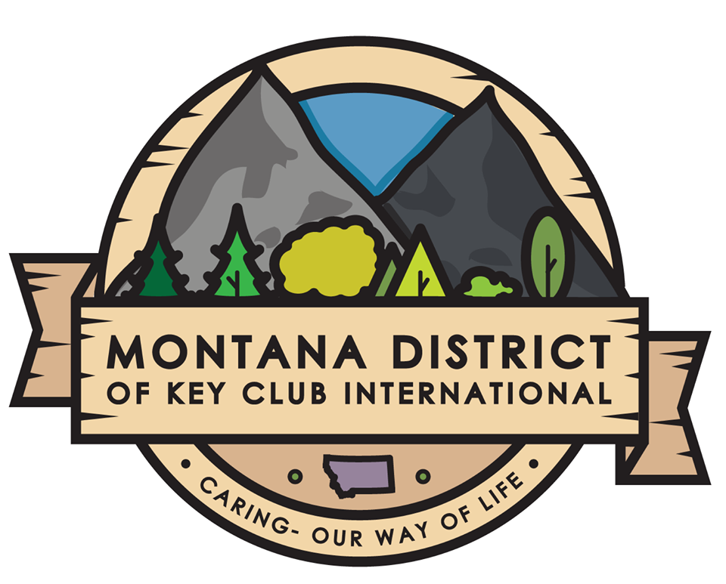

This section Includes:
- Club Registration Packet & Room List
- Montana District Youth Conference Checklist

Please mail all forms and nominations to:
Montana District of Key Club International
c/o Valerie Pachl
20 South Center
Miles City, MT 59301

Email: vpachl96@gmail.com

CLUB REGISTRATION FORM

Name of Club:
Please complete the following information for the advisor or adult responsible for receiving receipts, conformations, and answering questions concerning your registration.

Name: Position:
Address: City: Zip:
Phone: E-mail:

Indicate on the rooming list form the rooming assignments of those attending convention.
PLEASE COMPLETE THE SECTION BELOW (after first reading the notes)

- Number of registrants to be placed four (4) to a room x $125 = $

- Number of registrants to be placed three (3) to a room x $130 = $

- Number of registrants to be placed two (2) to a room x $140 = $

- Number of registrants to be placed one (1) to a room x $260 = $

- Number of District Board members (don’t include above) x $50 = $
(H) Other (i.e. Bus Driver) X $240 =$

Total amount being sent = A + B + C + D + E =$

PLEASE MAKE CHECKS PAYABLE TO MONTANA DISTRICT KEY CLUB (NO CASH PLEASE).
NOTES:
  - Chaperones and advisors please be sure you have added a room for yourself in the above table. Please specify whether you wish to be placed either 1 or 2 to a room.
  - If you have less than 4 Key Clubbers to a room, but wish to pay the lower rate, register those 4 to a room and we will fill the room for you. Please advise these Key Clubbers that they may have to be moved to another club’s room in order to accomplish this. If you have 3 to a room, in this circumstance, please designate the Key Clubber who would be most willing to move. We do not guarantee that all will be in the same room.
  - Any questions, please Contact Valerie Pachl 406-234-4920 ext. 266

I am aware that there must be a chaperone with our club upon arrival AND throughout the entire convention. I have read and agree to comply with the refund policy and all other terms regarding registration.

Dated this _____ day of _____, 2021 by _________________________________________________________
(Faculty Advisor)

Montana District Key Club
2021 Youth Conference Registration Rooming List

Please type or print all information to ensure accurate registration of individuals.
Please make additional copies of this for if needed to complete your registration.

Rm. | First Name  (To be printed on Badge) | Last Name  (To be printed on Badge) |  | Office Held |  | Gender | Room Type | Check One
 |  |  |  | Old | New |  | Q/T/D/S | Student | Adult
1.
2
3
4
5.
- Office held: please use “old” for outgoing officers and “new” for incoming.
- Room type: Q for quad; T for triple; D for double; S for single

2021 Youth Conference Convention Checklist
A step-by-step list of everything you need to register for YC

______Look over everything and make sure you understand
______Collect Individual Registration and Medical Release forms from members attending
(including district board members)
______Look over all the forms and make sure all information and signatures are present.
______Make your rooming assignments, with four people per room, on the rooming
assignment sheet.
______Complete club registration form
______Send Individual Registration forms, Medical Release, Paid-Member checklist, and Club Registrations
________Bus Drivers may stay at a different hotel if they wish or, you may include them with the club registration forms. If they do not participate in the convention (meals, etc.), the cost will be $240. Enter under part H – Other, and on the rooming list.

***Registration and Payment to Valerie Pachl by October 13th.
Valerie Pachl
20 N Center St
Miles City, MT 59301

***We CANNOT Guarantee ANYONE Rooms on Registrations Received AFTER
October 18th***
**Remember, rooms will be assigned on a first come, first serve basis.

